

**Faculty of Computing and Information Technology**

**Bachelor of Information Technology (Honours) in**

**Internet Technology Year 2 Semester 2**

**Academic Year 2025/2026**

**BMIT2023 Web and Mobile Systems**

**Short Report**

|  |  |  |
| --- | --- | --- |
| **Project Title** | **:** | Online Shopping System |
| **Tutorial Group** | **:** | RIT2(S3) - Group 1 |
| **Team Members** | **:** | Jennie Kim 00WMR00001  Kim Jisoo 00WMR00002  Lalisa Manoban 00WMR00003  Roseanne Park 00WMR00004 |
| **Tutor** | **:** | Mr. Liaw Chun Voon |

**A. Table of Content**

|  |  |  |
| --- | --- | --- |
| **No** | **Title** | **Page** |
| **A.** | **Table of Content** | **2** |
| **1.** | **System Modules Outline** | **3** |
| **2.** | **Entity Class Diagram** | **4** |
| **3.** | **Monetization Models** | **5 – 6** |
| **4.** | **System Screenshots** | **7 – XX** |

**1. System Modules Outline**

* Additional Features are highlighted in green

|  |  |
| --- | --- |
| **1. Security**  **PIC: Jennie Kim**   * Roles: Admin & Member * Login & Logout * Password Hashing * Password Recovery (Email) * Login Blocking * Captcha   **2. Admin & Member Maintenance**  **PIC: Jennie Kim**   * Admin Account Maintenance (CRUD) * Member Account Maintenance (CRUD) * AJAX Searching, Sorting and Paging * Block & Unblock Account * Member Registration * Email Verification (OTP) * Profile Photo Upload * Profile Photo Resizing & Cropping * Advance Photo Processing (e.g. Rotate) * Webcam Photo Capture   **3. Category & Product Maintenance**  **PIC: Kim Jisoo**   * Category Maintenance (CRUD) * Product Maintenance (CRUD) * AJAX Searching, Sorting and Paging * Product Photo Upload * Product Photo Resizing & Cropping * Advance Photo Processing (e.g. Rotate) * Webcam Photo Capture * Multiple Photos Upload * Drag-and-Drop Photos Upload * Product Stock Update   **4. Product Catalog**  **PIC: Kim Jisoo**   * Product Listing & Detail * Product Filtering (Category & Price Range) * Top Selling Products * AJAX Searching, Sorting and Paging * QR Code (Scan to Search Product) | **5. Shopping Cart**  **PIC: Lalisa Manoban**   * Shopping Cart (Add Item) * Shopping Cart (Update or Remove Item) * QR Code (Scan to Add Item) * AJAX Integration * Product Stock Checking * Wish List (Add Item) * Wish List (Remove Item) * Wish List (Transfer to Shopping Cart)   **6. Ordering & Payment**  **PIC: Lalisa Manoban**   * Checkout (Add Order) * Shipping Address (Add and Manage) * Payment (Stripe API) * Email Notification (E-Receipt) * SMS Notification (Order Created) * Product Stock Deduction   **7. Ordering Maintenance (Admin)**  **PIC: Roseanne Park**   * Order Listing & Detail * Order Filtering (Status) * Order Status Update * AJAX Searching, Sorting and Paging * SMS Notification (Status Updated) * Charts (Sale Reports)   **8. Ordering History (Member)**  **PIC: Roseanne Park**   * Order Listing & Detail * Order Filtering (Status) * Order Cancellation * AJAX Searching, Sorting and Paging * SMS Notification (Order Cancelled) * Charts (Purchase Reports)   **9. Others**  **PIC: Lalisa Manoban**   * Customer Support (Real-Time Chat) * Google Maps (Store Location)   **PIC: Roseanne Park**   * Product Review and Rating * Reward Point Handling |

**2. Entity Class Diagram**

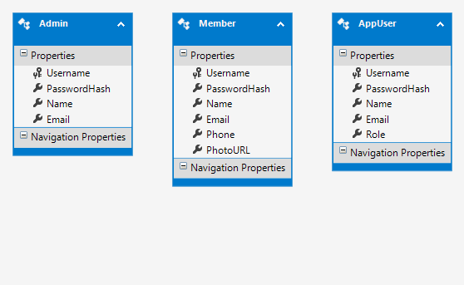

**3. Monetization Models**

We propose the following software monetization models for making our system sustainable:

**(A) License**

Discuss the monetization model. Describe in details how you would charge your clients and/or users. Provide a rough (but logical) estimate of the total incomes and revenues you will generate for the proposed monetization model. Estimate length: half a page.

**(B) Advertising**

Discuss the monetization model. Describe in details how you would charge your clients and/or users. Provide a rough (but logical) estimate of the total incomes and revenues you will generate for the proposed monetization model. Estimate length: half a page.

**(C) Transaction Fees**

Discuss the monetization model. Describe in details how you would charge your clients and/or users. Provide a rough (but logical) estimate of the total incomes and revenues you will generate for the proposed monetization model. Estimate length: half a page.

**(D) Support**

Discuss the monetization model. Describe in details how you would charge your clients and/or users. Provide a rough (but logical) estimate of the total incomes and revenues you will generate for the proposed monetization model. Estimate length: half a page.

**4. System Screenshots**

**(A) PIC: Kim Jisoo**

**1. Student Maintenance**

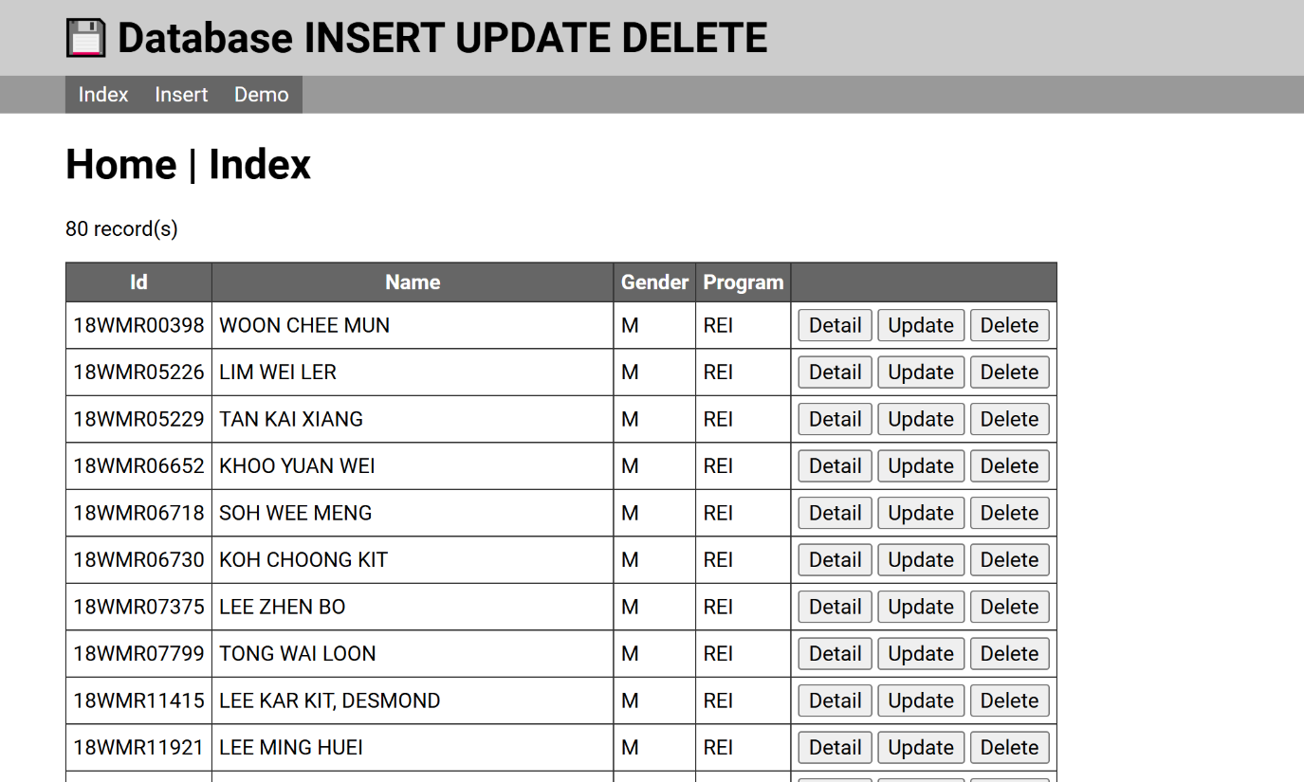

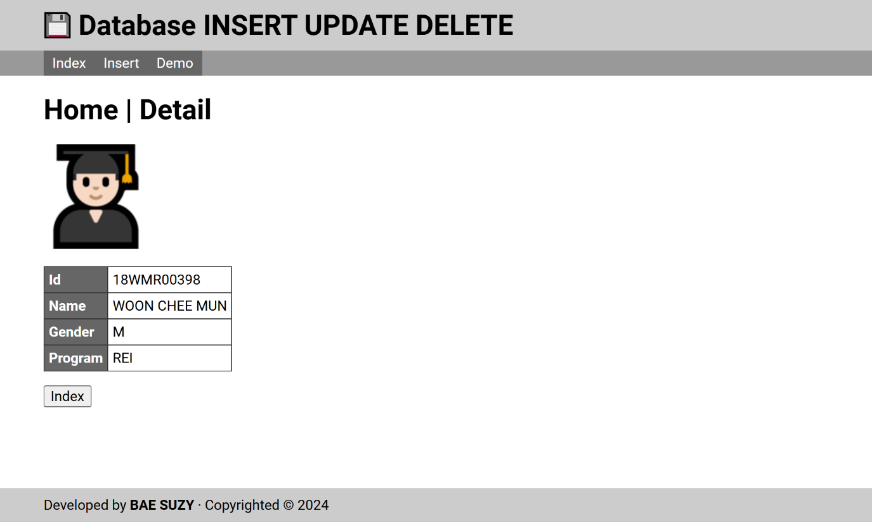

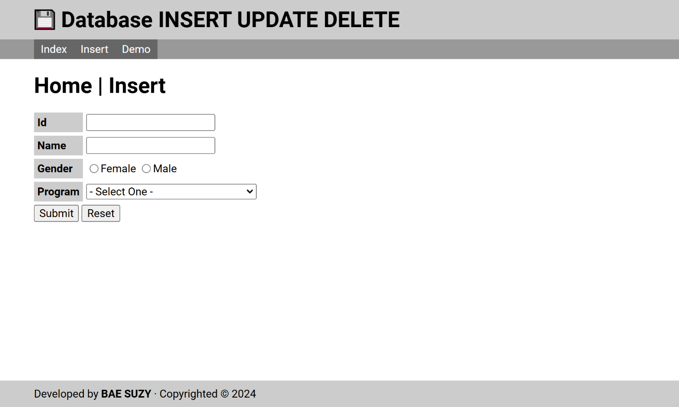

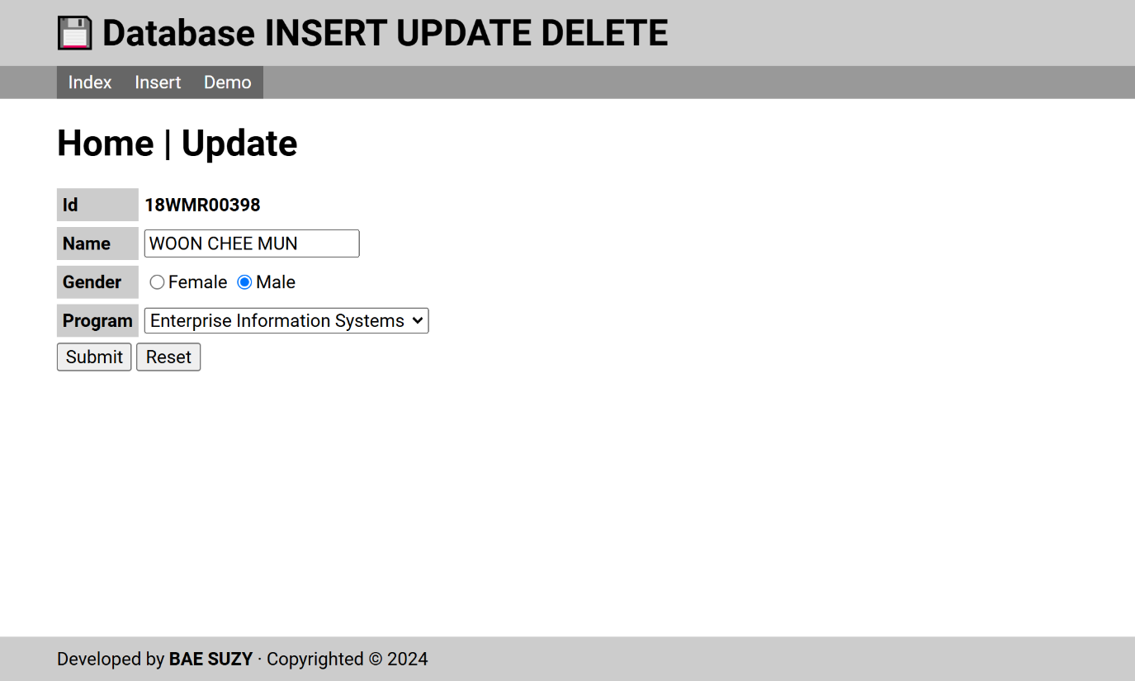

**2. XXX Module**

Screenshot

Screenshot

…

**3. XXX Module**

Screenshot

Screenshot

…

**(B) PIC: Jennie Kim**

**1. XXX Module**

Screenshot

Screenshot

…

**2. XXX Module**

Screenshot

Screenshot

…

**3. XXX Module**

Screenshot

Screenshot

…

**(C) PIC: Lalisa Manoban**

**1. XXX Module**

Screenshot

Screenshot

…

**2. XXX Module**

Screenshot

Screenshot

…

**3. XXX Module**

Screenshot

Screenshot

…

**(D) PIC: Roseanne Park**

**1. XXX Module**

Screenshot

Screenshot

…

**2. XXX Module**

Screenshot

Screenshot

…

**3. XXX Module**

Screenshot

Screenshot

…